GROUP PROJECT – TIDE POWDER

GROUP 10

Rashmi Savla

Akhilandeshwari Bekkary

Varun Himmatramka

Ann Le

Jimit Mehta

**OVERVIEW**

The data obtained was a grocery and drug store scanner data of laundry detergents along with customer and store demographics. We have done Analysis on this by role playing a Brand Manager to help accelerate the growth of the brand, Tide Powder to increase market share. We performed a competitive analysis amongst top performing powder products to bring business values and to provide insights.

Analysing current market scenario and applying statistical models to identify significant attributes contributes towards increase in sales. Performing analysis of data in today’s world is of the utmost importance. We accomplished this by deciding on multiple hypothesis, then understanding data and analysing it at brand level, segmenting customers and providing recommendations, insights from our key findings.

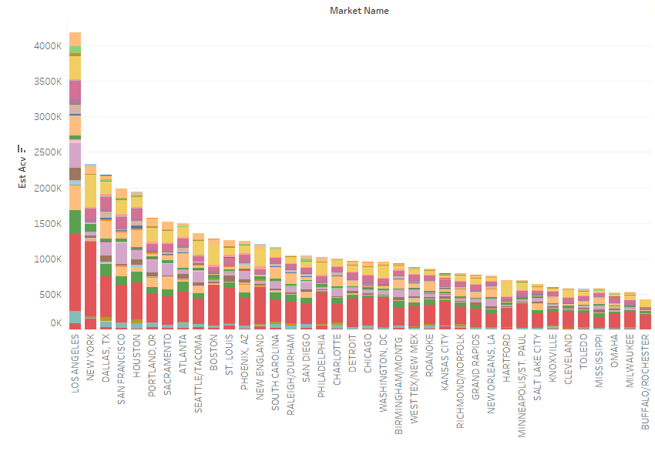

This visualization shows us the market share of powder throughout the country. We see that tide is has the most market share in all the cities. Los Angeles has the highest sales of Powder and New York is the second highest but again the sales in both the cities are almost the same in both the cities which means there is scope to increase Tide powder sales in Los Angeles.

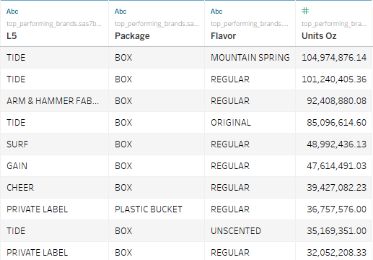

We observed that customers prefer Box packaging and Regular flavour for powder category detergents the US market. However, the combination of package and flavour which has highest sales is Box Package with Mountain Spring flavour of the brand Tide while Box regular stands second highest. Hence, we recommend that Tide Box Regular should be promoted more to increase it’s sales.

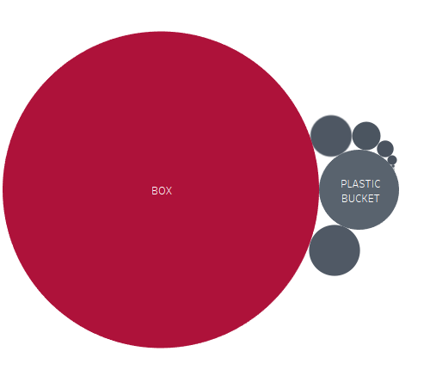 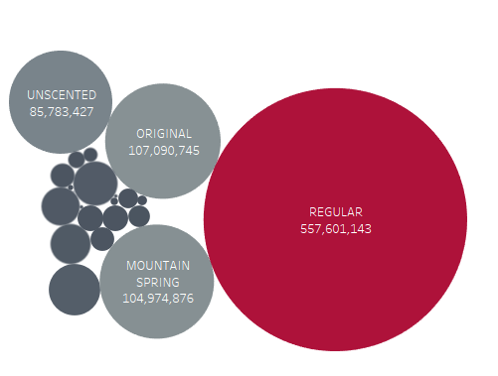

**Objective 1**: What are the effects of features and display on sales of Tide Powder? Intuition and Evidence.

**Method**: Proc Panel (Random one)

**Recommendation**: We should have features and display for the products which we need to increase sales for based on the package types and flavour.

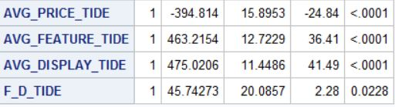

**Objective 2**: What are the demographic factors of top customers with Tide powder? Intuition and Evidence.

**Method**: Mixed Logit Model.

**Recommendation**: Monitor the activities with customers of these types to see any new trend. At the same time, focus direct marketing to other categories (probably using RFM to get more insights on action).

1. **Market share of powder laundry-detergent market: Grocery Store.**

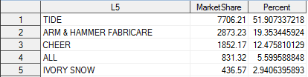Approximately, the top four brands above make 72% of US powder market, and Tide (1) already occupied 52%. Therefore, in MDC model, I will narrow down analysis on only this group since, as the big player in the market, we care more about competitors with potentially larger shares.

1. **A sneak peak into Tide powder’s top customers:**

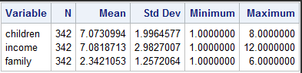

From the basic stats, an average household has either of a low income, family of two people, and various ages among kids ( implying to have kids).

However, there are more insights by diving into each demographic factor. The top households are identified to be a **couple(2), have low income (6) ($25000- $34999 per year), and have no children(8**). Respectively, kid groups 8, income level 6 and family size 2 have 80%, 16% and 42% of total units consumed.

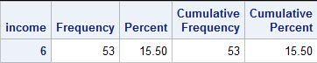 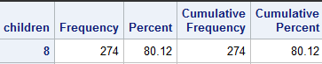 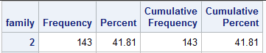

It seems there may be misunderstanding about children group factor. The basic stats show that households have kids, but, diving into factor “children”, the interpretation is opposite. However, It does make sense that the highest level under “children” is code 8, where the family size is larger than 0 but no children. This implies a household of only a single or couple. In fact, level 8 occupied 80% of total units consumed under “children” feature. **Therefore, the basic stats have misled the interpretation without enough evidence and further analysis.**

1. **As a result, use Mixed Logit Model to confirm this intuition with some statistical evidences.**

Screen%20Shot%202018-12-01%20at%204.24.39%20PM.png Screen%20Shot%202018-12-01%20at%204.24.43%20PM.png Screen%20Shot%202018-12-01%20at%204.25.13%20PM.png

Since Mixed Logit can capture even unobserved heterogeneity, the McFadden R-squared (0.5311) is higher than Multinomial logit model (R= 0.4208). Log Likelihood (-804) compared to that of Null model (-1715) is smaller, which also reflect an improvement of models. Also, AIC is 1648 and BIC is 1751.

The following features have significant coefficients in MDC model: price (mean), promotion (mean and SD), inc2, kid3. By direction of such effect, price_M means there is a lower likelihood of choosing a brand when price goes up. In this group of top powder brands, this makes some sense in term of macroeconomics. On the other hand, using promotion (= feature +display) on products will decrease the chance of a chosen brand in this market. The magnitude of these price and promotion will be shown through own and cross elasticity.

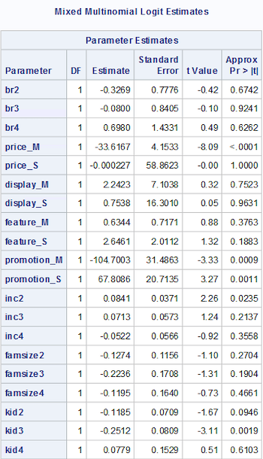

In own elasticity, when Tide increase the percentage in price and promotion by 1%, the probability of Tide being chosen will decrease by 0.94% and 3.94% respectively. In cross elasticity, when other brands than Tide increase price and promotion by 1%, the probability of Tide being chosen will jump by 2.67% and 0.21% respectively. In magnitude, the sensitivity customers will go more towards promotion on Tide’s action. However, on competitors’ action, market customers are more sensitive with price.

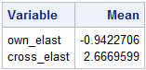 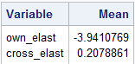

Price Elasticity Promotion Elasticity

Under demographic factors, inc2 has shown that a salary jump will pick up the likelihood of choosing Cheer (2) over Tide (1) (or over All and Ivory Snow since inc3 and inc4 are non-significant). This has shown Tide not being preferred by high income family, which gives some evidence to the idea that low-income households are truly the Tide’s top customers.

Also, with kid3, a higher level of “children group code” decrease the chance of All (3) to be chosen over Tide (1) ( or over Cheer and Ivory Snow). Level 8 under “children group code”, however, belong with Tide’s top families. Therefore, its higher chance of selection over all (3) somehow confirmed that a majority of Tide’s top households has no kids.

The family size shows no effect on brand selection, so the identity of couples as top customers can not be confirmed.

**Objective 3**: Which customers do we need to target for Tide powder? Intuition and Evidence.

**Method**: Loyalty Monetary Model.

We decided to segregated households based on their loyalty to our brand. To achieve this, we assigned each household a loyalty score based on the criteria below

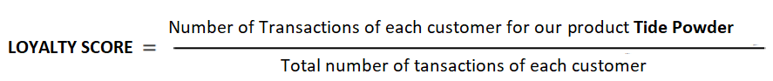

Based on their loyalty score, we divided the households into 4 categories:

Hero customers (who shopped for our brand 75% or more times)

Heroes in waiting (who shopped for our brand 50% - 75% of the times)

Lapsing Heroes (who shopped for our brand 25%- 50% times) Lost Cause (who shopped for our brand less than 25% of times)

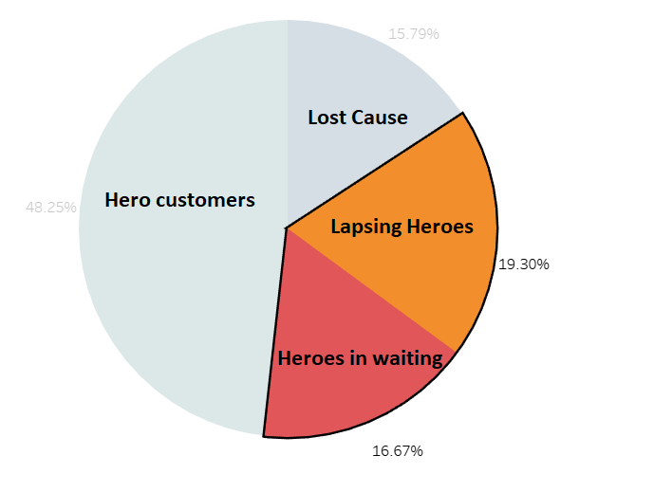

Loyalty Distribution Analysis based on Customer who purchased TIDE POWDER

In the above pie charts, we can see the distribution of Loyalty score for customers based on their brand preference. **We recommend to target below two segments:**

1. Heroes in waiting (who are about to become our hero customers) ~ 16%

*Provide them hero treatment and try to make them become heroes*

1. Lapsing Heroes(Switching Customers) ~ 19.30%

*Make regular attempts to re-engage*

We further analysed the above two segments based on **Monetary** factors. So divided customers further into 4 segments based on profit generated. Below are our findings for the same, **we recommend to target the segments that provide more monetary values (3, 4)**

